**23)**

**Aim:** To Design Deterministic Finite Automata using simulator to accept the string the end with ab over set {a,b) W= aaabab.

**Diagram:**

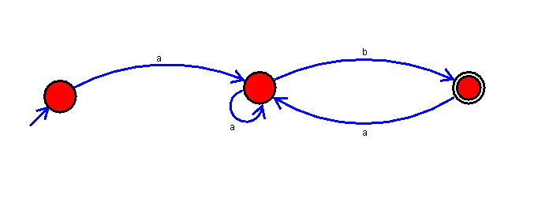

**Result:**

Thus, successfully executed Deterministic Finite Automata using simulator to accept the string the end with ab over set {a,b) W= aaabab.